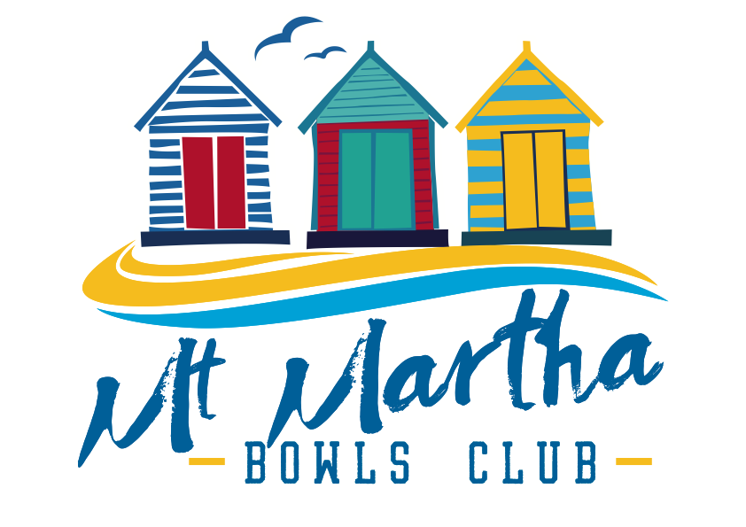
NEWSLETTER JANUARY 2021
Dear Member,
What a year 2020 was! Happy New Year. Let us hope that 2021 is a better year than 2020. We want to get back to our normal activities such as regular bowling, pennant, social bowls, club championships, regular Thursday triples, night owls, socialising, and those of us who travel in winter and want to get away as normal. Keep your fingers crossed that all this can happen this year without any significant changes.

For those who have been at the Club on Thursday and Friday this week you will have seen action around the Petanque Terrain (west green area). Our Petanque friends have been working hard and have installed half the wooden sides of the terrain and will have it completed within two working days. This is well ahead of schedule which is fantastic. Next week we have a meeting with Shire officials and hopefully work can start towards the end of January in taking off the top 100mm of the terrain and then depositing different layers of gravel in line with international standards. This will mean that there will be lots of action during February.

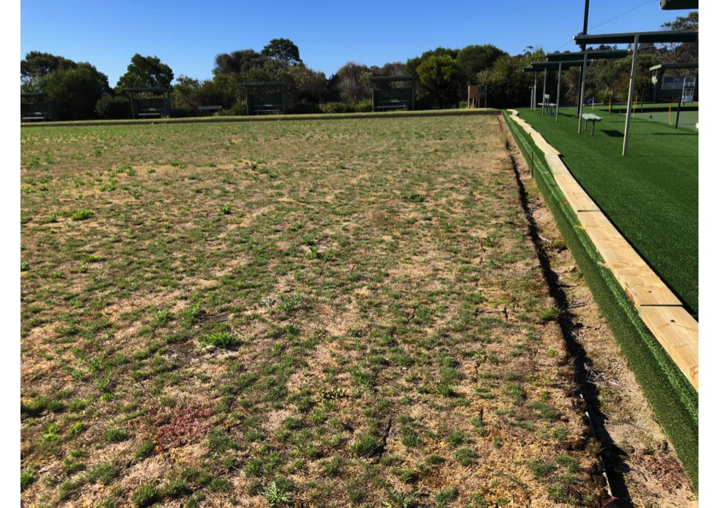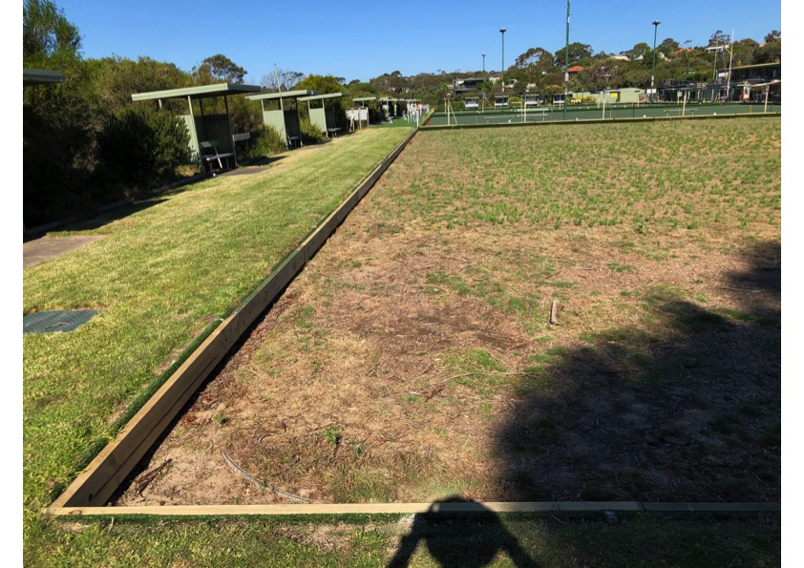

Timber ready for installation on eastern side Timber installed on western & northern sides
We are having a Special General Meeting of the Club at 4.00pm next Thursday 14 January following the completion of the Open Nominated Triples. The only business to be transacted is:
“To pass a special resolution to make a name change to our Registered Incorporated Association name of Mt Martha Bowls & Social Club Inc to Mt Martha Bowls, Petanque & Social Club Inc”
I encourage all Members to be at the meeting or complete proxy forms. Applications forms for Members wishing to vote by proxy are available in the foyer of the Club and must be returned completed and lodged in the Secretaries box or emailed to the club at mmbowls@mmbcinc.com.au before 12.00 p.m. on Wednesday 13 January. Proxies will only be valid and accepted if they are received by this date and time.

This month we welcome 42 “new” Members from Mount Martha Mornington Petanque Club into our Club. They are very enthusiastic about their future at Mount Martha and I encourage Members to make them welcome when you see them. We will have an official welcome for them at a date to be announced shortly.
Stay Covid safe and enjoy your bowling.

Tony Spring
Chairman
WHAT’S HAPPENING WITH FINANCES!!

What a sight yesterday - 22 teams playing in the Mercedes-Benz January Mixed Triples. It was a great day - sunny, both greens full, into the Clubhouse for lunch & we were able to enjoy a drink from the Bar afterwards together with entering the excellent meat tray raffle donated by Jacob's & Lowe. Wonderful day & let's hope there are many more to come.
Classic Pairs: To date 20 of the 32 teams entered have paid so we anticipate an excellent event on Wednesday 10/2/21 & Thursday 11/2/2021.
Xmas Raffle: Thank you to all the members who entered our "electronic" raffle. The surplus was $1,352.00.
Bendigo Bank Support: The Club received a "Covid Support" donation of $1,500.00 from the Bendigo Bank. The Club certainly appreciates the Sponsorship & Support from the Bendigo Bank.
Barefoot Bowls: This event for 20/21 has started very well with good weather & plenty of visitors to Mt Martha. Unfortunately due to covid restrictions we are limited to 100 players per session. Last week we had to turn another 100 people away.
Bunnings BBQ Sunday 17/1/2021: This is another big fundraiser for the Club. "Thank You" to the Members who offered to help raise another $1500.
Petanque Club: Certainly looking forward to the Petanque Club joining us. The Club has opened a Bendigo Bank A/C with the Petanque Club ready to receive their contributions which will cover the costs of constructing the 24 piste terrain.
Good Bowling to everybody & let's stay "Covid Safe" by following all the necessary rules.

Celia Patrick
Club Treasurer

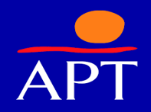

WHAT’S HAPPENING WITH MEMBERSHIP!! 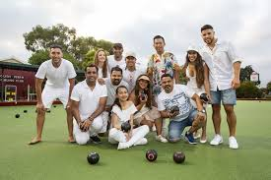
Since the start of the new financial year, we have entered 19 new playing members on to the club register and there are 3 others undergoing initial coaching. A group of residents from the Martha Bay Retirement Village visited the Club on Wednesday January 6th. With the assistance of Kevin and Vicky Higgins they bowled for about 45 minutes before coming up to the clubrooms for light refreshments put on by Elizabeth. As a result, 9 membership application forms were handed out. There are a further 10 residents who have expressed an interest in visiting us but who were unable to attend on Wednesday. As our average age creeps up each year, it is particularly important that we continue striving to attract younger members.
We are trying to develop a closer relationship with the Mt Martha Community Centre & they have indicated they will be promoting us on their new noticeboards on the corner of the Esplanade and Dominion Roads.
From a Welfare point of view please continue to help by sanitising the tables and chairs after use. We should also be wearing masks when inside the clubhouse, although of course they can be removed when enjoying a drink or eating food.

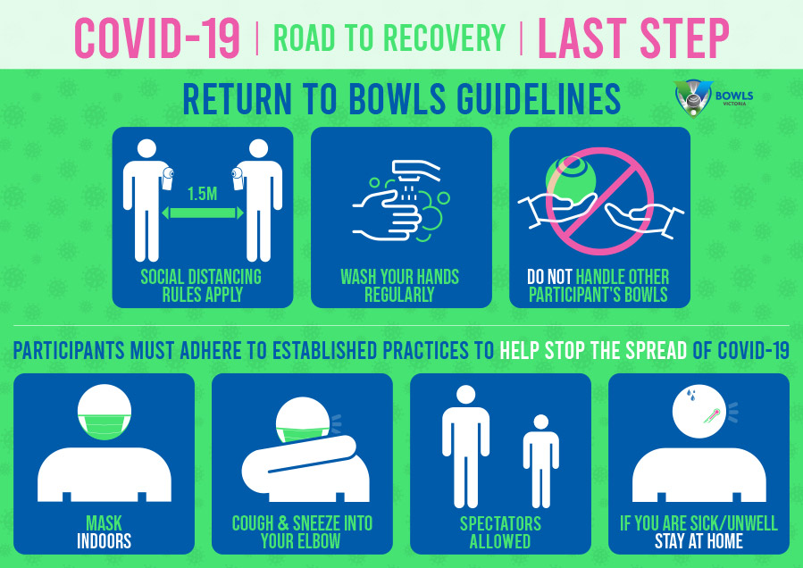

We should continue to follow the current Bowls Vic guidelines that all attendees shall:
* sanitise their hands upon arrival and leaving the venue.
• Leads shall also sanitise their hands regularly
• All other players should sanitise their hands after every 6 ends.
The club has provided 4 sanitisation stations at the end of each green for this purpose.
If you will be in the clubhouse for more than 15 minutes you need to register your arrival and departure times on the sheets in the foyer.

Stay Safe and Healthy.

Bill Gomme
Membership Director

WHAT’S HAPPENING WITH SPONSORSHIP!!

I am pleased to report that after several attempts over my time in this position I have finally secured a sponsor for Social Bowls.

Prime Cuts Meats in McLaren Place Mornington have agreed to sponsor by way of four $25 meat vouchers each month up to the end of our bowls season at the end of May. The pleasing aspect was they made a particular reference to the wish that their sponsorship should be directed to our social bowlers. I am very hopeful this support will turn into a long-term commitment for our Social Bowls Section during our summer season.

I can also report I have had an approach from a present sponsor to extend their sponsorship commitment with us. This is at a very early stage but I am very hopeful of successful outcomes with an emphasis towards our new Petanque facility.

May I also take this opportunity on behalf of Barbara and myself to wish you all a very happy and healthy new year.

Ron Turner
Sponsorship Director

WHAT’S HAPPENING WITH BOWLING!!

The Pennant season is about to recommence and we have entered an extra side in the Mid-Week Open Division 6 to fill the bye which was created when a club withdrew at the last minute. This will enable most people wanting to play pennant to get a game.

We have been able to conduct our regular Thursday Nominated Triples in the usual format of two games with a lunch break and some refreshment at the end which has been long overdue. We can only hope that this continues with the new Covid outbreaks occurring. At the Bowls Section Committee meeting it was decided to make one of the Thursday Triples events as club select which hopefully will entice some of our newer bowlers to enter and mingle in.

Club Championships have commenced with entry sheets in the clubhouse for Novice, Pairs and 2 Bowl Singles events so enter your name and join in.

Our next special event will be on Australia Day. Breakfast and Bowls to start the celebrations off (depending on Covid restrictions). Club select and casual dress will be the format so everyone can join in.

Club jacket orders are now at 27 and we are meeting with the supplier next week to get things moving. A new supply of club caps has arrived so for $20 you can get a new cap with the beach boxes logo. Contact Margaret McInerney if interested.

Barefoot bowls is booming with 100 people attending and a waiting list. Helpers are welcome especially at the 6.00pm start and clean up about 8.00pm so spare an hour and help out.

We have obtained a sponsor for Wednesday Social Bowls and this Wednesday we will be playing for $25 vouchers from Prime Cuts in Mornington. This is the first of the regular social bowls days for the year so come along and join in and support our sponsor.

Kevin Dungey
Bowls President

